|  |  |  |  |
| --- | --- | --- | --- |
| Project Name: Enter Here   |  | | --- | | Name of Project [Enter Here]*.*  Email: [Enter Here]  Website: [Enter Here] |  |  | | --- | | Trent Hall – The Jones’ |   Name of Project [Enter Here]*.*  Email: [Enter Here]  Website: [Enter Here]  Trent Hall – The Jones’ | logo-placeholder |

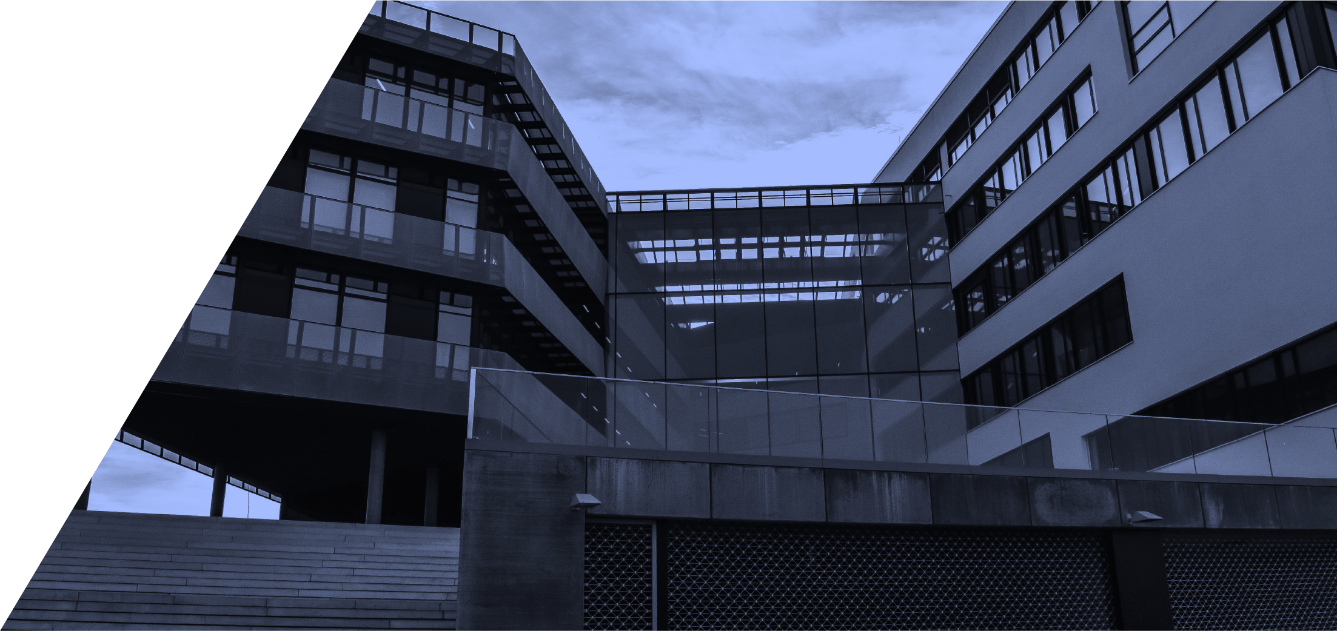

Contents

*Executive Summary* 3

Introduction 4

Describe your scenario 4

Target audience 5

Report outcomes 5

Recommendations 7

Conclusion 9

Summary 9

|  |  |
| --- | --- |
| Assessment Report - Submission details | |
| Participant Name: | [Enter Here]Jack McLovin |
| Topic: | [Enter topic here]Scenario Residential Build |
| Unit Code & Name: | [UNIT CODE] – [Unit title]BSBESB402 – CPCCBC4002 – CPCCBC4006 – CPCCBC4021 - CPC40120OL15SNE(C2) |
| Trainer/Assessor Name: | [Enter Here]Yaser Farag and Denis Crow |
| Submission date: | ***____ / ____ / ____21/09/2023*** |
| Work submitted:   * evaluation of steel trussed roof vs timber pitched roof in appropriate climate zone for durability, fire resistance, and cost effectiveness * tolerance criteria selected that apply to the better chosen materials * climate zone tolerances that differ from Katherine to metro Melbourne * tolerance installation and assembly identification and checking relevant to construction industry Australian standards * Contingency plan for unavailability or unsuitability of material for project | |
| Declaration: | In submitting this work I declare that no part of any assessment I submit has been copied from another person’s work, except where clearly noted on documents or work submitted. I declare that no part of any assessment I submit will have been written for me by another person. I understand that plagiarism is a serious offence that may lead to disciplinary action. |
| Participant Signature:  (Insert Name) | [Enter Here]Jack Don McLovin |

|  |
| --- |
| *Executive Summary* |

## Introduction

|  |
| --- |
| Report Written By: [Enter Here] Jack Don McLovin  Date: [Enter Here] 21/09/2023  Project Details: [Enter Here] Scenario – Residential Build |

## Describe your scenario

[Enter Here]

The Trent Hall in Katherine needs to be roofed with either steel truss or timber pitch. Depending on the climate zone, we need to determine the durability, fire resistance and cost effectiveness of each, and then to recommend one based on also the serviceability and compliance with Australian Standards. We need to make use of tolerance criteria for the selected material and name the difference between doing this in Katherine and in Melbourne. Allowable tolerances for installing and assembling needs to be identified and checked and made relevant to the work and the construction industry Australian standards. As well as contingency plans for the case of unavailability or unsuitability of the materials.

## Target audience

[Enter Here] Labourers, Clientelle, Builder, Sub-contractors, Building Code Inspectors

## Report outcomes

[Enter Here]

*The Jones have asked the manage Trent Hall to evaluate whether a steel trussed roof would outperform a timber pitched roof in that climate zone. Please include the following when preparing your comparison*

[Enter Here]*.*

*Durability*

[Enter Here]*.*

*Fire resistance*

[Enter Here]*.*

*Cost effectiveness*

[Enter Here]*.*

## Recommendations

*Based on the comparison, it is my recommendation that,*

[Enter Here]*.A steel trussed roof*

*It is a suitable material in terms of its*

* *Application*

*because it is a very hot area in Katherine, such that fires are far more likely to occur than in Melbourne for example, so Steel won’t burn compared to the timber.*

* *Durability*

*Steel is much stronger than timber, and will hold in the tropical winds of Katherine. Plus it can hold a lot of weight so is unlikely to deteriorate over time as compared to the rotting and cracking of wood.*

* *Serviceability*

*The steel can be re-coated (paint or galvanise) once the sun and rain has worn it’s coating away, in order to prevent rust.*

* *cost effectiveness*

*Timber is a lot cheaper, but will need to be replaced more often in Katherine’s climate. Thus it is more cost effective to use Steel.*

* *Compliance with Australian standards*

*Steel is a lot stronger than timber, so using steel for the roofing will ensure that the strong winds won’t rip apart the timber and leave the house without a roof when such a scenario occurs.*

*State two tolerance criteria that apply to the material you have selected*

*Tolerance criteria that apply to the material construction Process*

* [Enter Here]*.*

*Thickness of steel truss, angle of triangular cross-sections, truss length, truss height, bath-tub curve of truss reliability over time (deterioration vs breakage).*

*How will allowable tolerances for installing and assembling materials be identified and checked, in regard to the nature of the work and relevant construction industry Australian standards?*

*The supplier will check the reliability, and we will inspect that in the report, meanwhile all other tolerances will be checked with measuring tape and calipers, and a protractor.*

*Contingencies would you have in-place in case specified materials are unavailable or unsuitable for this project?*

Import from over-seas.

## Conclusion

*In Conclusion*

[Enter Here].Steel is preferred as it won’t burn, however it can’t be in direct sunlight otherwise it’s strength will go.

## Summary

General overview of the report.

Dot point this section of all the areas covered examples may include

[Enter Here]*.*

Timber will burn too quickly, and so steel will have to be used.

Tolerances can be checked by supplier and builder, to show the correct product was shipped.